
Treatment for Voiding dysfunction

The following recommendations have been suggested by your doctor to treat your child’s urinary problems:

______ TIMED VOIDING: Have your child urinate every 2 hours BY THE CLOCK. Try
to establish a schedule that is the same at home and at school. We can provide
you with information on an alarm to help remind your child to use the bathroom.

______ TIMED VOIDING WATCH.

______ DOUBLE VOIDING: After your child urinates, he/she should wait a moment
and try to go a second time while still sitting on the toilet. This will help to insure
that the bladder is completely empty.

______ KEEP A VOIDING CALENDAR/DIARY: The voiding diary is used to record the
amount that your child urinates, the time of day that they urinate and their bowel
movements (make sure to describe their bowel movements). This diary may be
filled out when your child is at home in the evening and on weekends so that the
doctor can see several days worth of your child’s pattern. MAKE SURE TO
BRING THIS DIARY WITH YOU TO YOUR NEXT APPOINTMENT.

______ MIRALAX (MAINTENANCE): ______ mixed in 8 ounces of juice or water once
daily. This is to help regulate your child’s bowel movements. It is thought that
constipation plays a part in contributing to urinary problems. (SEE NEXT PAGE
IF YOUR CHILD NEEDS TO DO A BOWEL CLEAN OUT).

______ 100% CRANBERRY JUICE: To help acidify the urine and prevent urinary tract infections.

______ ANTIBIOTIC: ____________________________________________.

______ NYSTATIN OINTMENT: Apply to genital skin when it begins to turn
red. Use twice a day for 5 days.

______ WASH GENITALIA DAILY, using a mild soap and be sure to rinse all soap
away. Help your child with this to be certain that the cleaning is thorough.

______ BLADDER MEDICATION: __________________________________.

______ CONSTIPATION PROTOCOL: Involves the use of Mineral Oil/Milk of
Magnesia/Miralax as directed by your physician. See attached form.

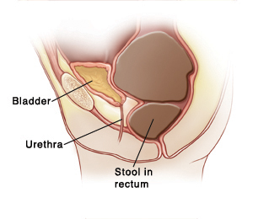
Continue this regimen until your doctor tells you to stop. If you run out of your medications, please contact our office at 210-615-1600 for a refill, or if you have any questions regarding any of these recommendations, or if you think your child has a urinary tract infection (fever >101, foul smelling urine, pain on urination or blood in urine.) Our nurses can be reached from Mon – Fri, 8:00 AM to 5:00 PM.

