
Hydronephrosis

How does the urinary system work?
The urinary system consists of the kidneys, the bladder, and the ureters. The kidneys filter the blood to remove waste products and form urine. The urine flows from the kidneys down through the ureters to the bladder. From here it passes through another tube called the urethra to the outside when urinating.

The ureters tunnel through the wall of the bladder at an angle to form a flap that acts as a valve. There is also a ring of muscle (sphincter) at the junction of the bladder and the urethra that tops urine leaking out in between times of going to the bathroom to pee. When peeing, the muscles of the bladder wall squeeze the urine out of the bladder. At the same time the muscles in the sphincter should relax to let the urine flow down the urethra.

The valves between the ureters and the bladder prevent urine from flowing backwards into the ureters, so that all the urine in the bladder is emptied at one time. As the urine leaves the bladder, the valves stop the normal high pressure from affecting the kidneys.
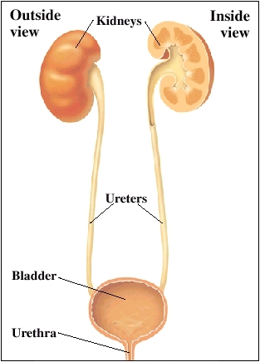

What is hydronephrosis?
Hydronephrosis is a condition that can occur during pregnancy, where a baby’s kidneys fill up with urine and become larger. There are many reasons why this can happen. Hydronephrosis can also occur in adults, but this usually develops for completely different reasons and is treated in a different way.

Even if hydronephrosis is diagnosed before birth, this should not cause any symptoms in the mother and should not affect care during pregnancy, other than possibly having a few more ultrasound scans. Hydronephrosis does not usually cause a baby any problems before birth, but he/she may need close monitoring and assessment after birth to discover what is causing the hydronephrosis.

It is often diagnosed before a baby is born, as the enlarged kidneys can be seen on an ultrasound scan. Hydronephrosis can also be diagnosed after the baby is born using ultrasound scans.
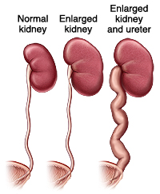

What causes hydronephrosis and how is it treated?
There are many causes of this common condition known as hydronephrosis, including:
- A blockage, which can occur between the kidney and the ureter (ureteropelvic junction or UPJ), between the bladder and the ureter (ureterovesical junction or UVJ) or in the urethra (posterior urethral valves). If the cause is a blockage, your child may need an operation called a pyeloplasty to remove it. Please see our Pyeloplasty or UPJ handout for more information.
- Vesicoureteric reflux occurs when the valve between the ureter and the bladder does not work properly and urine can travel back up in the kidney. If the cause is VUR, the child will probably be treated using antibiotics. Please see our Vesico-ureteric reflux handout for more information.
- Ureteric duplication, which affects about 1% of all people. Children with ureteric duplication have two ureters leading from a kidney to the bladder, instead of one. Occasionally, they have a blockage at the lower end of one of the two ureters called an ureterocele.
- A multicystic dysplastic kidney (MCDK) is a non-functioning kidney made up of many cysts. Sometimes these shrivel up and disappear, but some need to be removed at a later stage. If the cause is a multicystic kidney, the affected kidney may be removed, leaving the normal one on the opposite side or it may be left in place as long as it is doing no harm. Having only one kidney will not have any significant effect on your child’s health.

If the hydronephrosis is diagnosed during pregnancy, early treatment will consist of monitoring with ultrasound, to check that the baby is growing normally and the kidneys are not getting too large. The baby will usually be born by a routine delivery. If the hydronephrosis is causing problems for your baby, the fluid may need to be drawn off of the baby’s kidneys during the pregnancy. This is very unusual.

After the baby is born, the hydronephrosis will be monitored using ultrasound scans and other tests. The overall treatment for hydronephrosis depends on what is causing it:

- If the cause of the hydronephrosis is an obstruction and this is removed, your child’s kidneys will be able to work properly.
- If the cause of the hydronephrosis is VUR that is not too severe, your child’s kidneys are also likely to work properly.
- If the cause of the hydronephrosis is severe VUR, the outlook may be less good. Your child may need an operation to correct the reflux and his or her kidneys may be damaged. However, the earlier the hydronephrosis is discovered, the better the outcome for your child.

