Biofeedback
Your child has been scheduled for biofeedback therapy. These sessions are focused on improving his/her bladder function.

Biofeedback is tool used to teach your child to identify the external urinary sphincter. This is the muscle that opens and closes the bladder to keep urine in or let urine out. Once your child identifies the sphincter, the therapy will help them gain control over it so that during urination your child will relax appropriately and empty their bladder completely. An empty bladder will decrease the recurrent urinary tract infections and incontinence episodes.
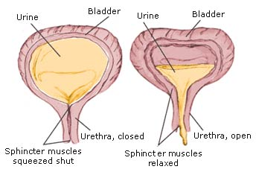

Preparing for your biofeedback session
- Your child will need to urinate when they show up, so drinking 1-2 hours prior to your visit is recommended.
- They will have EMG stickers placed on the stomach, legs and buttocks. These stickers will record how their muscles are working during urination.
- Your child will urinate in a special toilet where a Uroflow measurement will be taken. This is a measurement of how much urine is voided, how long it takes to start voiding and what the voiding pattern is once it has started.
- After voiding, your child will have a bladder ultrasound scan to determine if they have completely emptied their bladder.
Learning to gain control.
- The EMG stickers will be linked to an interactive animated video game where your child can identify the muscle activity and thus learn to control it better.
- Your child will be asked to squeeze the muscle as to prevent a bowel movement or gas passage and then they will be asked to squeeze the muscles as to prevent urination
- Once your child learns to isolate the muscle, they will practice contracting and relaxing it
- It is recommended that your child practice this 10-20 times daily at home
- Keep a voiding diary and bring it to your next session, this will help us track your progress.
- Positive reinforcement and a reward system is also recommended; you may consider a sticker chart for relaxed “timed” voiding every 2 hours.

